Race Report

Week 9, 2010

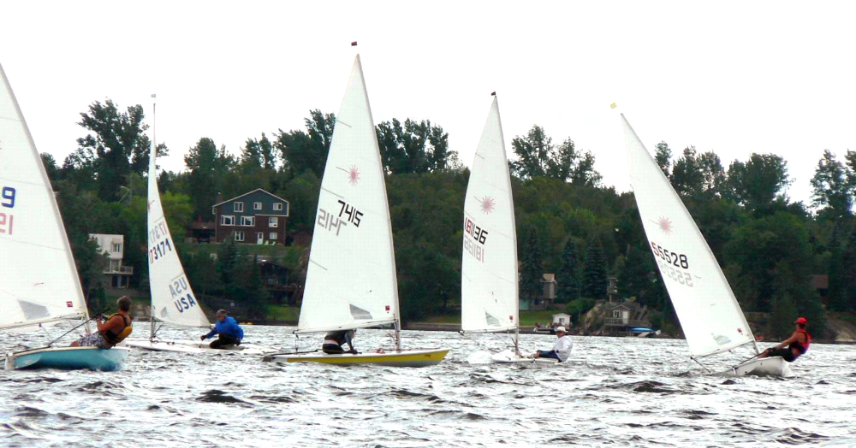

Lots of action at the upwind mark, NorthShore Regatta 2010.

This week, a report on the Y-Flyer Internationals held in Ohio.

Tuesday:
Strong winds again buffeted the club as Tuesday night racing was on. Judy set a modified Olympic triangle course with a gibe mark and 2 reach legs to add to the excitement. Three races were run in winds of 10 gusting to 15 knots from the southwest. As temperatures neared 30 degrees, spending any time in the water was enjoyable, just not during a race. Seven boats were rigging in the strong wind: John, Gary, Scott, Jeff, Mike, Indrek and Dave were all there. Parker and Michelle were out on the 29er and Sylwin with Bradley (sailing school bronze 5 student) was also out on a Laser II. A number of downwind crashes highlighted, may-be not so much for those who crashed, the evening, but they add to the excitement. The reaches were fast and the up winds saw a number of crosses and position changes as sailors looked for shifts and lifts. Dave was king of the day going 1,2,2 showing great ability to stay in front and out of trouble. Mike was next going 4,1,1. Fourth, what’s up with that… OK, then he goes and wins the next 2 races. Indrek was next at 3,3,3, showing he can stay up with leaders in strong blow. Gary followed next going 2,4,4. Wow, what a difference a day makes, Sunday he could not keep up, but today he was on fire, way to go Gary. Jeff was next with 5,5,5. He benefited from Scott’s untimely death roll in the 1st race as he passed him while Scott was enjoying a cool dip. In the other 2 races he was close to leaders all around the course. Scott, as previously described, death rolled in the 1st race and he John fought it out in the other 2 races. John went 7,6,7 and proved he great patience on the up winds as he made some good gains. On the reaches he said, “I just can’t keep up to you young guys.” The 29er showed fantastic speed on the reaches as it sliced through the water and although I didn’t see much of the Laser II, I’m sure they had a good time

Thursday:
No sailing due to no wind, therefore, no fun.

Sunday:
Again, a day of little wind and no sailing.

Y-Flyer Internationals

On the weekend of July 22-23-24-25, three of our Y-Flyer’s traveled to Ohio to compete in the 2010 Y-Flyer International Regatta. Pierre, Rob and Suzanne and Warren with son Alex all made the trip. Thursday was spent getting the boats measured and rigged up, Friday the racing started, with winds reaching 20 knots it was too strong for Alex, so unfortunately he had to be replaced. As luck had it, a sub was found and Warren could continue to race. Strong winds continued to blow all weekend leaving the sailors pretty exhausted. Rob reported he was disqualified in one race due to bias judging and sour grapes on the part of the American boat and even though another boat was there to tell his side of the story, the jury did not listen and Rob was out. Overall results had Pierre and crew Madeline Mehler in 10th, with Rob and Suzanne in 15th and Warren and crew Lisa King in 16th. Congratulations to all who competed.

Remember, “Keep the people in the boat and water out of the boat.”

The Not So Anonymous Laser Racer.

